Decolonise Your Mind Training Overview and Framework

Decolonise Your Mind Training
Developed by Kate Harriden and Nicola Lambert, through ongoing work at Catchment Studio.
Kate Harriden is a Wiradyuri woman who has worked with water on Ngunnawal Country for over 20 years. Nicola Lambert is an Irish woman who has worked and lived on Ngunnawal Country for 16 years. Both feel deeply connected to Ngunnawal Country through their shared and individual work and relationships with Ngunnawal Country and Community. Catchment Studio's collaborative platform aims to create projects and outcomes that support relational work centred on connection, care, and responsibility for Ngunnawal Country.

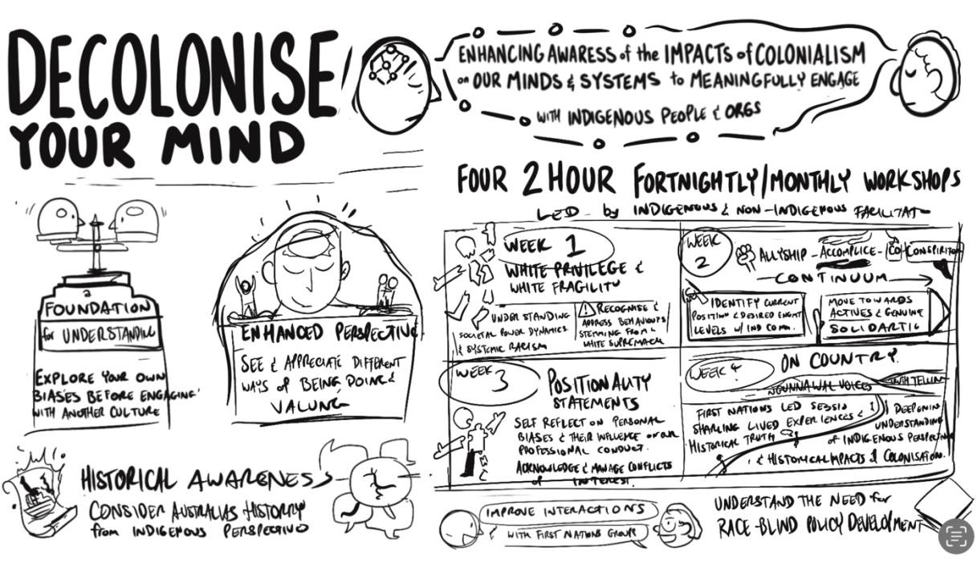

Decolonise Your Mind, Why?
The Decolonize Your Mind training aims to confront and challenge participants, encouraging profound shifts in their understanding of both the impact of colonisation and themselves. Those who engage openly and genuinely in this workshop series will gain deeper insights and be better equipped to engage in cultural awareness training and navigate the complexities of working with communities, systems, and people affected by colonialism.

Recent Developments
Approved and recommended by the United Ngunnawal Elders Council (UNEC) and Dharwa
Ngunnawal Caring for Country Committee (DNCCC)

Decolonise Your Mind Training Overview and Framework

Primary Audience
The Decolonize Your Mind (DYM) training is intended for a broad non-indigenous audience, including government teams and various organisations, to promote cultural safety and bias awareness. The training consists of online components, self organised Pod- enquires and truth telling session.

Participants attend On Country Truth Telling session after completing the online components. This session is a high-level Truth – telling session is delivered by an Indigenous facilitator. This is necessary to prepare the ground for non-Indigenous people to receive and embrace future cultural awareness training and move towards safer engagement with community.

Facilitator Structure
DYM is delivered by two facilitators: one Indigenous and one non-Indigenous. This structure supports cultural safety and offers multiple perspectives.

Safety for Indigenous Facilitators
As the training material can trigger, having Indigenous and non-Indigenous facilitators creates cultural support and safety. The Indigenous facilitator, with lived experience of bias and unsafe cultural encounters, is supported by their non-Indigenous counterpart.

To avoid potentially triggering experiences, Ngunnawal facilitators do not lead the online sessions. This approach helps manage the emotional and psychological load, since course participants may hold positions of power that directly or indirectly impact Ngunnawal Country and Community.

Preparation for Truth-Telling
Participants engage in reflective work to understand their personal and professional biases before engaging with Ngunnawal Custodians on Country. This ensures they are better prepared to receive and truly hear the Ngunnawal community.

Familiar Safety for Participants
Having a non-Indigenous facilitator provides participants with a sense of familiar safety, allowing them to recognise aspects of themselves in the facilitator.

Decolonise Your Mind (DYM): Unpacking Biases and
Building Relationships
An Invitation
Catchment Studio are excited to offer Decolonise Your Mind Training. To ensure the safety and well-being of both facilitators and participants, attendance is voluntary rather than mandatory. Just as the ground must be open to receive rain, participants need to come ready to engage openly and reciprocally. The topics covered in this training are sensitive and may be triggering for both participants and trainers. Therefore, it is essential that those who attend do so with a willingness to engage from a place of mutual respect and openness. To ensure some comfort among the necessary discomfort, the maximum number of participants per workshop series is 16. It is strongly recommended that participants attend all sessions. The Decolonise Your Mind (DYM) training framework combines online learning, self-organised pod-based inquiry, and a truth-telling session.

Decolonise Your Mind (DYM) Training Framework
The Decolonise Your Mind (DYM) training framework combines online learning, self-organised pod-based inquiry, and an in-person Truth-Telling session. An optional group positionality statement workshop is also available.
- Facilitated Online Modules
These sessions cover key topics such as White Privilege and Fragility, Allyship to CoConspiratorship, and Positionality/Relationality. Participants will engage with these concepts through facilitated discussions, videos, and reading materials.
- Pod-Based Inquiry
Participants will work in small groups to reflect on and discuss the session content. These pods provide a space for open, honest dialogue, encouraging deeper exploration of personal insights and challenges.
- Truth-Telling Session
This session forms the heart of the training. A high level truth telling session is conducted in person and on Country or online, tailored to the sector, group, or organisation receiving the training. It connects participants with the lived realities of the historical and ongoing impacts of colonisation.

- Group Positionality Workshop
Following the main training, participants can attend a workshop focused on creating a collective positionality statement. This session bridges individual reflection with group accountability, fostering shared responsibility and understanding.

Sample Program Schedule
Welcome Package (Pre-Course access): Access to Mighty Network platform with resources and program information.
10-week program
Introductory Session – Welcome & Pod Setup: Facilitated online orientation and pod formation (1 hr).
Session 1 – White Privilege and Fragility: 2 hr facilitated session.
Session 2 Self-Led Pod Enquiry – Reflection and discussion with post-session questions (2 hrs, scheduled program time).
Session 3 – From Allyship to Co-Conspiratorship: 2 hr facilitated session.
Session 4 Self-Led Pod Enquiry – Reflection and discussion with post-session questions (2 hrs, scheduled program time).
Session 5 – Exploring Positionality and Relationality: 2 hr facilitated session.
Session 6 - Self-Led Pod Enquiry – Reflection and discussion with post-session questions (2 hrs, scheduled program time).
Session 7 – Truth-Telling: 2 hr on Country Session
Session 8 - Self-Led Pod Enquiry – Reflection and discussion with post-session questions (2 hrs, scheduled program time).
Session 9 – Collective Positionality Statement: 2 hr facilitated session.
Session 10 - Self-Led Pod Enquiry – Reflection and discussion with post-session questions (2 hrs, scheduled program time).
Pod Based Enquires – Integral to learning
Pod enquiries are not optional; they are central to the relational learning process. Each pod runs for 2 hours and is scheduled as a weekly session, ensuring dedicated time for reflection, dialogue, peer learning and pre-reading and listening activities supporting participants to prepare for upcoming sessions. Pods also provide a foundation for building an ongoing practice and framework beyond the program, enabling participants to continue these conversations and carry their learning forward.

Quote for DYM Training
DYM Package - 10 weeks + intro session please email Yuma@catchmentstudio.com
Includes: Welcome package & materials, 5 × facilitated online sessions, 5 x Pod enquiry guidance and activities, on Country Truth-Telling session.

Commitment to Ngunnawal Priorities
This program is approved and recommended by the Ngunnawal Elders Council. All profits are reinvested into Ngunnawal-led projects, guided by Ngunnawal priorities, grounded on Ngunnawal Country, and developed in alignment with the Ngunnawal Design Principles and Approaches.

